PHYSICS – ORDINARY LEVEL 2021

2021 Question 1
A student carried out an experiment to measure the acceleration due to gravity g.
An object was allowed to fall through a known distance s and the time t for the fall was measured.

- Draw a labelled diagram of the apparatus used in this experiment.
- How did the student measure the distance s?
- How did the student measure the time t for the object to fall?
- How did the student improve the accuracy of the time t that was used?
The student recorded the following results.
s (m) | 0.4 | 0.5 | 0.6 | 0.7 | 0.8 | 0.9
t (s) | 0.29 | 0.32 | 0.35 | 0.38 | 0.40 | 0.43

- The value for g, the acceleration due to gravity near the surface of the Earth, is 9.8 m s⁻².
From the table, when the distance s is 0.4 m the time t is 0.29 s.
Use this data and the formula $g=\frac{2s}{t^{2}}$ to calculate a value for g.
- Use the results to calculate two other values for g and calculate their average.
- The maximum distance used is 0.9 m. Why does the student not use a greater distance?

- Why did the student measure the time for 20 oscillations rather than the time for one oscillation?
- Use the data to draw a suitable graph to calculate the acceleration due to gravity, g.
- Hence determine g.

2021 Question 2
A student performed an experiment to verify Boyle’s law by investigating how the volume V varied with pressure p of a fixed mass of gas.
The student recorded the following results.
V (cm³) | 19 | 17 | 15 | 13 | 11 | 9
p (kPa) | 106 | 118 | 133 | 154 | 181 | 223

- Draw a labelled diagram of the apparatus used in this experiment.
- How is the pressure varied in this experiment?
- Each time the pressure is changed, the student must wait before taking the reading for volume. Explain why.
- Boyle’s law states that for a fixed mass of gas, pressure is inversely proportional to volume.
For each value of V in the table above, calculate $\frac{1}{V}$ to three decimal places.
- Plot a graph on graph paper of p against $\frac{1}{V}$.
- Use your graph to calculate the volume of the gas when its pressure is 140 kPa.

2021 Question 3
A student carried out an experiment to measure f, the focal length of a converging lens.
- Draw a labelled diagram of the apparatus used in this experiment.
- On your diagram, indicate and label the object distance u and the image distance v.
- Name the instrument used to measure the object distance and the image distance.
- How did the student know that the correct image distance had been found?
- State the formula used to calculate f.
- The student placed an object 16 cm in front of the converging lens.
It produced an image at a distance of 48 cm from the lens. Calculate the focal length of this lens.
- Why will this experiment not work if the object is placed very close to the lens?

2021 Question 4
A student carried out an experiment to measure l, the specific latent heat of vaporisation of water.
Steam at 100 °C was passed into cold water in a copper calorimeter.
The student recorded the following results.

Mass of empty calorimeter | = 0.0894 kg
Mass of calorimeter and cold water | = 0.1327 kg
Initial temperature of calorimeter and cold water | = 20 °C
Final temperature of calorimeter, water and added steam | = 36 °C
Final mass of calorimeter, water and added steam | = 0.1341 kg

- Draw a labelled diagram of the apparatus used in this experiment.
- Calculate the mass of the cold water (A).
- Calculate the mass of the added steam (B).
- Calculate the increase in temperature of the calorimeter and cold water (C).
- Calculate the decrease in temperature of the steam (D).
- Use your values for A, B, C and D to complete the following calculations to find l.

Heat lost by steam = Heat gained by water and calorimeter

m_{steam}l + m_{steam}c_{water}Δϴ_{steam} = m_{water}c_{water}Δϴ_{water} + m_{cal}.c_{copper}Δϴ_{cal}.

B × l + B × 4200 × D = A × 4200 × C + 0.0894 × 390 × C

(specific heat capacity of water = 4200 J kg^{–1} K^{–1}; specific heat capacity of copper = 390 J kg^{–1} K^{–1})

2021 Question 5
A student performed an experiment to investigate the variation of current I with potential difference (voltage) V for a metallic conductor.
- Name the instrument used to measure voltage.
- Name the instrument used to measure current.
- How did the student change the voltage across the conductor?
- The student recorded the following results.

I (A) | 0 | 0.06 | 0.12 | 0.18 | 0.24 | 0.36
V (V) | 0 | 1 | 2 | 3 | 4 | 6

- Use the data to plot a graph on graph paper to show the relationship between I and V.
- Describe the relationship between current and voltage for this conductor.
- What would you notice if the experiment was repeated using a filament bulb instead of a metallic conductor?

2021 Question 6
Answer any eight of the following parts (a), (b), (c), etc.

- A student arranges a metre stick so that it is in equilibrium.
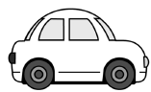
Explain the underlined term.
- A car starts from rest and has an acceleration of 6 m s^{–2}.
Calculate the distance it travels in 12 s.
Now some students aren’t great with maths questions so to help you we have included a completely unrealistic image of a car. You’re welcome.
- Water has a density of 997 kg m⁻³. Calculate the pressure due to water at a depth of 214 m.
- Complimentary colours mix to form white light. Name the secondary colour which mixes with red light to form white light.
- What is the Doppler effect?
- Draw a diagram to show how light is transmitted along an optical fibre.
- Coulomb’s law may be written as $F=\frac{1}{4πε}\frac{q_{1}q_{2}}{d^{2}}$ .
What do the letters 𝐹, 𝑞, and 𝑑 stand for in this expression?
- State the SI unit of (i) magnetic flux density, (ii) capacitance.
- The picture on the right is an X‐ray tube. The target in an X‐ray tube is usually made of tungsten.
What property of tungsten makes it suitable for this use?
- Silicon is an example of a semiconductor. What is a semiconductor?
- Draw a diagram to outline the Bohr model of the atom.
- What is the photoelectric effect?
(acceleration due to gravity = 9.8 m s^{–2)}

2021 Question 7
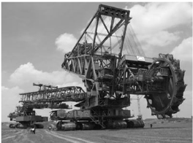
The Bagger 293 excavator is the world’s largest land vehicle, with a mass of 14200 tonnes. (1 tonne = 1000 kg)
Bagger 293 has a maximum speed of 0.17 m s⁻¹.
Bagger 293 has a large momentum.

- What is meant by momentum?
- State the principle of conservation of momentum.
- Explain why Newton’s second law of motion is consistent with the principle of conservation of momentum.
- Calculate the momentum of Bagger 293 when it is moving at its maximum speed.
- Bagger 293 is moving when it picks up a stationary load of 2700 tonnes.
Would this cause its speed to increase or to decrease?
Explain your answer.

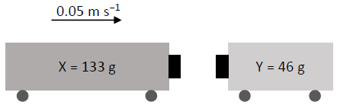
Toy train X has a mass of 133 g and is moving along a track at a velocity of 0.05 m s⁻¹ to the right.
It collides with toy train Y of mass 46 g which is at rest.
The two trains stick together and move down the track together.
- Calculate the initial momentum of train X.
- Calculate the speed of the two trains immediately after the collision.
- In which direction do the two trains move after the collision?
- Calculate the loss in kinetic energy during this collision.
- What happened to the kinetic energy that was lost in the collision?

2021 Question 8
A wave can be described as a travelling disturbance that transports energy from one point to another.
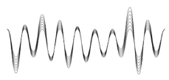
- Describe an experiment to show that sound waves need a medium to travel through.
- What type of waves do not need a medium to travel through?
- Waves can be classified as either transverse or longitudinal.
Distinguish between transverse and longitudinal waves.
(A labelled diagram may help your answer.)
- The frequency of a certain radio station is 107 MHz.
It broadcasts waves of length 2.804 m. Calculate the speed of the radio waves. (28)

Light and sound waves both display the properties of reflection, refraction, diffraction and interference.
- Describe one example of the reflection of sound waves.
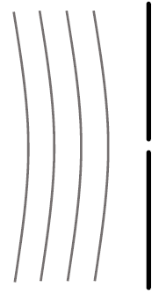
- Light strikes a glass block with an angle of incidence of 23°.
The light undergoes refraction as it travels from the air into the glass. The angle of refraction is 15°.
Calculate the refractive index of the glass.
- The wave fronts shown below diffract as they pass through the gap.
Copy and complete the diagram to show this wave undergoing diffraction.
- Describe an experiment to show that sound undergoes interference.
- Light waves undergo polarisation but sound waves do not.
Explain with the aid of a labelled diagram what is meant by polarisation.

2021 Question 9
As electrons move through a metal, the metal resists this movement. The electrons collide with atoms of the metal and lose kinetic energy. This lost energy is converted into heat.
- Define resistance.
- Name the instrument used to measure resistance.
- The photograph shows a rheostat, which is a variable resistor.
When the sliding contact is moved, the current flows through a different length of wire, thus changing the resistance of the rheostat.
State the relationship between resistance and length.

A 4.8 m length of circular nichrome wire has a radius of 0.2 mm.
Nichrome has a resistivity of 1.1 × 10⁻⁶ Ω m.
- Calculate the circular cross‐sectional area of the wire.
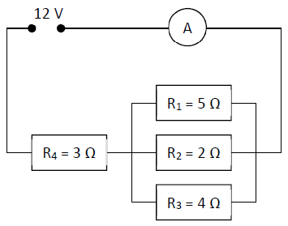
- Calculate the resistance of the wire.

- Examine the circuit diagram shown on the right.
- Show that the combined resistance of the three resistors in parallel
(i.e. resistors R1, R2 and R3) is 1.05 Ω.
- Calculate the total resistance in the circuit.
- Calculate the current flowing through the ammeter, A.

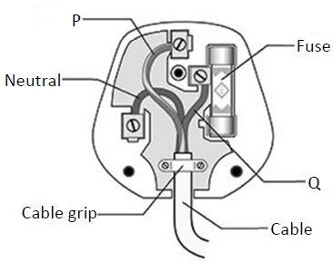
The diagram on the left shows the parts of an electrical plug.
The wire labelled P is yellow and green.
- What is the function of this wire?
(x) Name the wire labelled Q.

2021 Question 10
A periscope is used on a submarine. The periscope uses plane mirrors to allow a person on the submarine to see above the surface of the water.
- Describe how a periscope works.
Your answer should include a labelled diagram showing the path of a ray of light through the periscope.
- State the laws of reflection of light.
- Describe an experiment to demonstrate the laws of reflection.
- Light can also be reflected from spherical mirrors. Two types of spherical mirrors are concave mirrors and convex mirrors.

- Copy the ray diagram below into your answerbook and complete it to show how a real image is formed in a concave mirror.

An object of height 2 cm is placed 17 cm in front of a concave mirror.
An image with a height of 3 cm is formed.
- Calculate the magnification.
- Calculate the image distance.
- State one use of a concave mirror.
- State one use of a convex mirror.

2021 Question 11
The normal human body temperature is 37 °C.
This temperature increases when a person is fighting an infection.
The thermometer in the photograph on the right measures infrared radiation emitted from a person’s forehead.
- Heat may be transferred by radiation and by conduction.
Name the other way in which heat may be transferred.
- Distinguish between heat and temperature.
- Convert the normal human body temperature from degrees Celcius (°C) into kelvin (K).
- Thermometers are designed to make use of thermometric properties.
What is a thermometric property?
- State one example of a thermometric property.
- Two thermometers may not give the same reading for a person’s temperature, even though both thermometers are working correctly. Explain why this is the case.
- The solar constant (solar irradiance) is a measure of how much radiation from the Sun falls on each square metre of the Earth’s surface in one second. It has a value of 1.36 kW m⁻².
- The diagram on the right shows a rectangular garden.
On a particular day, sunlight falls on the garden for exactly 12 hours.
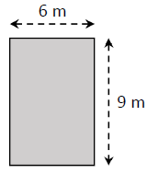
Calculate the area of the garden.
- Calculate how many seconds there are in 12 hours.
- Calculate how much energy will fall on the garden in the 12 hours.
- Heat is transferred at different rates depending on the material it is moving through.
Describe an experiment to compare the rate of conduction through different solids.
- U−value is a measure of the rate of heat loss through walls and windows.
Describe two ways of reducing heat loss from a building.

2021 Question 12
Lise Meitner was an Austrian physicist who was the first woman to become a full professor of physics in Germany. In 1938, together with chemist Otto Hahn, she discovered nuclear fission.
- What is nuclear fission?

Fission reactors are used to generate electricity.
- What is the function of the control rods in a fission reactor?
- A fission reactor is surrounded by shielding. What is the purpose of the shielding?
- What material is used as shielding?
- State one disadvantage of nuclear fission.
- Meitner never won a Nobel Prize for her discovery, although Hahn did. She was honoured after she died by having an element named after her. The element is called meitnerium, Mt.
How many electrons are in an atom of Mt? (Refer to page 79 of the Formulae and Tables booklet.)
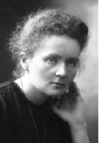
Marie Curie also has an element named after her, curium, Cm. Curie was the first woman to win a Nobel Prize, which was for her study into radioactivity.
- What is meant by radioactivity?
- There are three types of nuclear radiation: alpha, beta and gamma.
Which type of nuclear radiation is the most penetrating?
- Describe an experiment to compare the penetrating power of the three types of nuclear radiation.
- Curie also developed techniques for isolating radioactive isotopes.
What are isotopes?
- One isotope of curium is ${Cm}_{96}^{247}$
How many neutrons are in this isotope?

2021 Question 13
Read the following passage and answer the questions below.
The Millikan Oil Drop Experiment
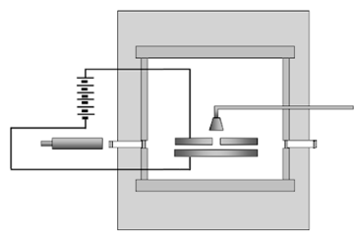
An experiment performed by Robert Millikan in 1909 determined the size of the charge on an electron. He also determined that there was a smallest unit charge. He received the Nobel Prize for his work.

The experiment Millikan performed involved putting a charge on a tiny drop of oil using X‐rays and measuring how strong an applied electric field had to be in order to stop the oil drop from falling.
By attaching a battery to the plates above and below the chamber, Millikan was able to apply an electric voltage. The electric field produced in the chamber by this voltage would act on the charged oil drop.
If the voltage was just right, the electromagnetic force would just balance the force of gravity on a drop, and the drop would hang suspended in mid‐air.
Using a microscope, he measured the radius of the drop. Given that the density of the oil was known, Millikan could calculate the mass of each oil drop. Using this mass, he could calculate the weight of one drop. He could then determine the electric charge on the drop.
By varying the charge on different drops, he noticed that the charge was always a multiple of 1.6 × 10⁻¹⁹ C, the charge on a single electron.
Adapted from ffden‐2.phys.uaf.edu/212_fall2003.web.dir/ryan_mcallister
  - What did Millikan determine with his 1909 oil drop experiment?
  - What is the size of the charge on one electron?
  - X‐rays are made by accelerating electrons across an X‐ray tube. How are the electrons produced in an X‐ray tube?
  - A drop has a volume of 2.03 × 10⁻¹⁷ m³ and a density of 886 kg m⁻³. Calculate the mass of the drop.
  - Draw the circuit symbol for a battery.
  - In the oil drop experiment, Millikan applied an electric field between the plates until the drop no longer moved up or down. What is an electric field?
  - Sketch the electric field that is formed between two oppositely charged parallel plates.
  - Show the forces acting on the drop when it is not moving up or down.

14. Answer any two of the following parts (a), (b), (c), (d).

2021 Question 14 (a)

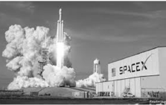
A SpaceX Falcon 9 rocket carrying two astronauts launched from the Kennedy Space Centre in Florida on 30th May 2020. The rocket was headed for the International Space Station (ISS).
- The rocket was visible in Irish skies 15 minutes after take‐off.
At that time it had travelled a distance of 6484 km.
Calculate the rocket’s average speed during this part of the journey.
- The rocket later docked on the ISS. The ISS orbits the Earth every 93 minutes.
How many full orbits of the Earth does the ISS complete each day?
- Newton’s law of universal gravitation describes the force of attraction between the ISS and the Earth.
State Newton’s law of universal gravitation.

The ISS is located 400 km above the Earth’s surface. At this altitude, the acceleration due to gravity is 90% as strong as it is on the Earth’s surface. Before travelling to the ISS, the mass of one of the astronauts was measured to be 85 kg.
- Calculate the astronaut’s weight on Earth.
- What is the astronaut’s mass at the altitude of the ISS?
- Calculate the astronaut’s weight at the altitude of the ISS.
(acceleration due to gravity on Earth’s surface = 9.8 m s⁻²)

2021 Question 14 (b)
Lightning is a naturally occurring electrostatic discharge. It is caused by an imbalance between two electrically charged regions, usually a cloud and the ground.
- As charge builds up on a cloud, the cloud induces a charge on objects on Earth.
Explain how objects can be charged by induction. (A labelled diagram may help your answer.)
- Static electricity builds up in the cloud and releases 0.9 GJ of energy in a time of 0.3 ms as it discharges.
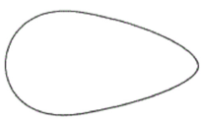
Calculate the power generated when lightning discharges.

- Draw a diagram to show the distribution of charge on a pear shaped conductor.
- Describe an experiment to show that static charge accumulates on the outside of a metal object.

2021 Question 14 (c)
Magnetism is the force exerted by magnets when they attract or repel each other.
- What is a magnetic field?
- Describe an experiment to plot the magnetic field around a bar magnet.
- Draw a diagram to show the magnetic field around a current‐carrying conductor.
- How could a student show that a current‐carrying conductor experiences a force in a magnetic field?
- State one use of magnets.

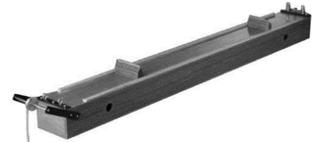

2021 Question 14 (d)
Sounds are produced when something vibrates.
- What is the unit of sound intensity level?
- Resonance is the transfer of energy between two bodies with the same natural frequency.
Describe an experiment to demonstrate resonance.
- A sonometer, shown above, can be used to investigate the relationship between the frequency of a stretched string and its length. State this relationship.

Waves on a stretched string travel at a speed of 380 m s⁻¹.
When a stationary wave is set up on a string, the distance between two adjacent nodes is 40 cm.
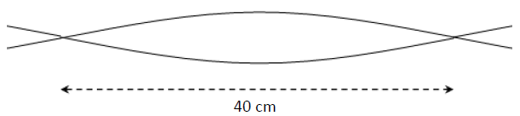
- Calculate the wavelength of the wave.
- Calculate the frequency of the wave.

